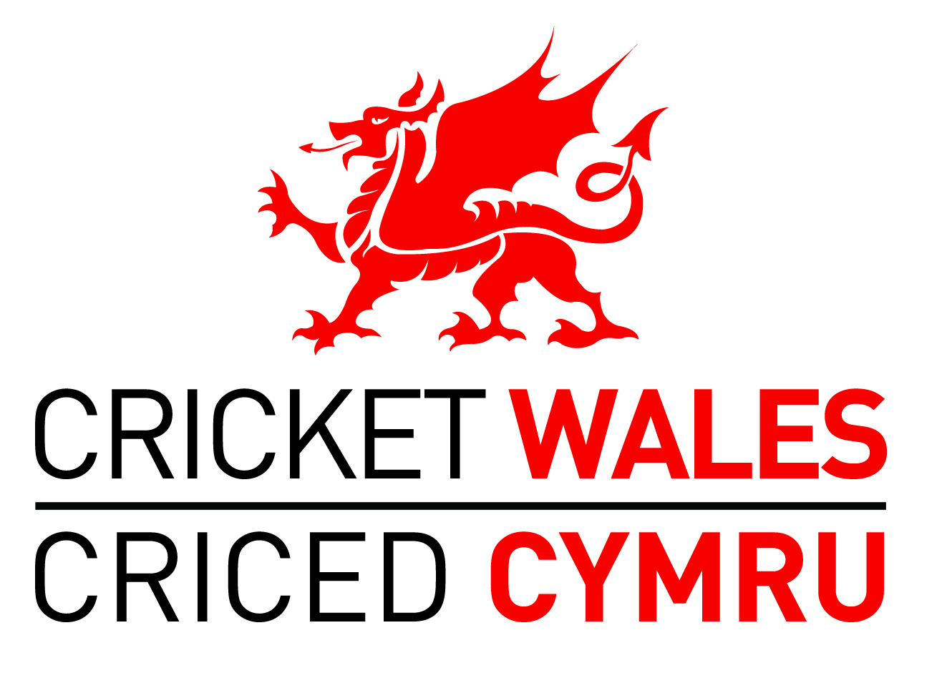

CRICKET WALES U13 & U15 CUPS

ECB NATIONAL QUALIFIERS

ENTRY FORM 2019

Club:

Youth Organizer Name: Email Address:

U13 Contact | U15 Contact | Fixture Secretary*
Name:  Home Tel:  Mobile Tel:  Email: | Name:  Home Tel:  Mobile Tel:  Email: | Name:  Home Tel:  Mobile Tel:  Email:

*Only complete the Fixture Secretary column if the Contacts are unable to arrange fixtures themselves

Please enter one team in the U13 Competition at a fee of £10: * YES/NO

Please enter one team in the U15 Competition at a fee of £10: * YES/NO

Please enter one team in the U13 ECB National Qualifier at a fee of £10 *YES/NO

Please enter one team in the U15 ECB National Qualifier at a fee of £10 *YES/NO

*I enclose a cheque for payable to ‘Cricket Wales Ltd’

*We are paying by BACS to the Account No: 30949157 at Bank Sort Code No: 54-21-33.

*Please delete where applicable

Please email this form to huw.darling@cricketwales.org.uk by 4th March 2019 at the very latest and return a hard copy with payment to: Huw Darling, 5 Derwen Close, Cefn Road, Blackwood, NP12 1JD by 25th March 2019 at the very latest

