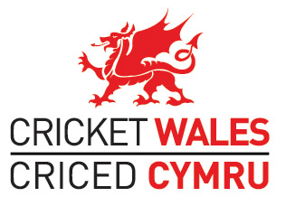

CRICKET WALES TALENT PROGRAMME MANAGER
PERSON SPECIFICATION

Cricket Wales is seeking to appoint a highly motivated leader with a talent development background to implement a new Long Term Player Development system throughout Wales, working closely with Glamorgan Cricket. The role is fundamental to the aspiration of producing ‘Great Teams’ as defined in the ECB strategy ‘Cricket Unleashed’
The successful candidate will have:
- Outstanding leadership skills proven within or outside of cricket. The role involves recruiting, leading, challenging and supporting a team of Talent Centre and Age Group coaches and managers

- Experience of developing young talent gained from within or outside of cricket

- A commitment to the principles of Long Term Player Development and the ability to successfully promote it to others. A detailed programme has already been agreed between Cricket Wales and Glamorgan Cricket

- Strong credibility amongst Welsh pathway coaches or the ability to gain it within a short space of time. This may be through an ECB Level 3 or 4 qualification (or equivalent), but could also be through alternative means

- Excellent communication and management skills/experience

- The proven ability to develop a system and to ensure it is successfully implemented centrally and remotely

- A commitment to ensure the new programme runs to a tight budget

- A full driving licence and commitment to travel throughout Wales and England

- A commitment to working the unsociable hours linked to the new programme

- Up to date DBS and Safeguarding certificates and a strong commitment to providing a safe environment in which young people can develop to their full potential.

