HPCC Ladies

Hawarden Park’s ladies’ section was set up in 2006 and are currently the only ladies’ team in North Wales playing competitive, hardball cricket. The squad has players of all ages and abilities, from the girls just starting to play senior cricket at 13 up to players in their 60s with abilities ranging from complete beginners to current and former Wales players. As there are no other ladies’ teams in North Wales, Hawarden play in the Cheshire Women’s Cricket League and are currently in Division 3; finishing 2nd in 2019 along with winning the Development Knockout Cup. The team’s recruitment has been helped by the women and girls’ development officer for North Wales, with players from as far as Dolgellau and Pwllheli travelling to play for Hawarden.

The ladies’ section are a big part of the club at Hawarden, with members always involved with club events from fundraising challenges to junior training nights. Hawarden ladies also host a friendly match against the Cheshire Cobras blind and visually impaired team every year, giving members of the club an opportunity to try a different perspective of cricket. It took 6 years but in 2019 we finally beat the blind team!

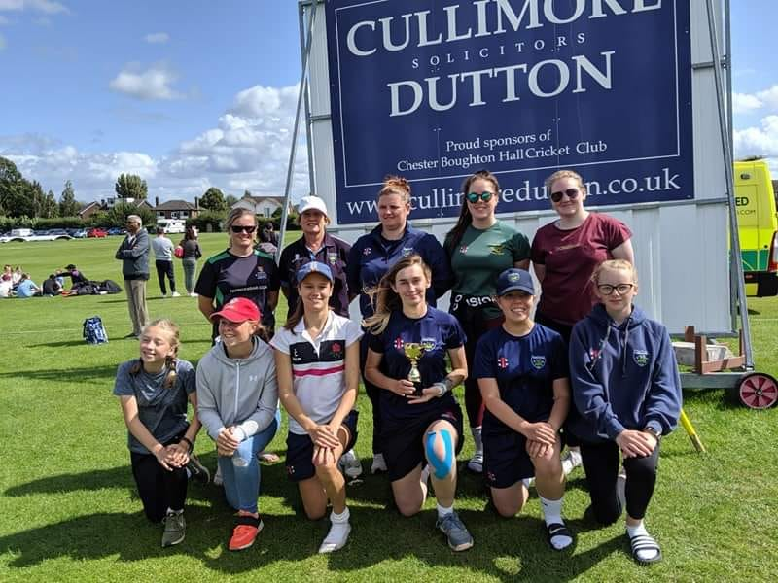

\\\\\

CWCL finals day 2019 – development KO champions.

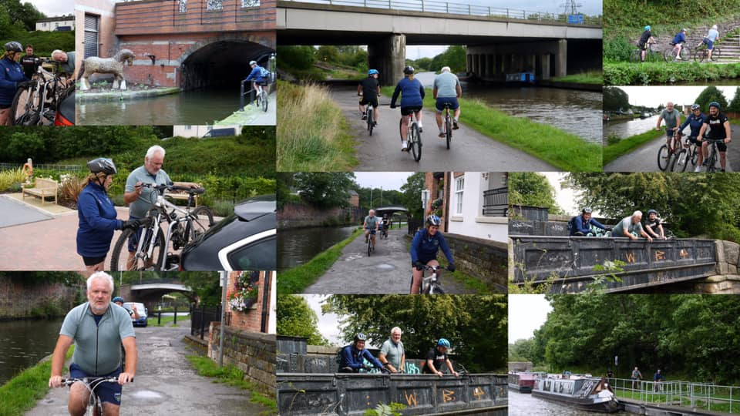
2019’s fundraising challenge – Fi Wynne representing the ladies’ team in the 100mile cycle.

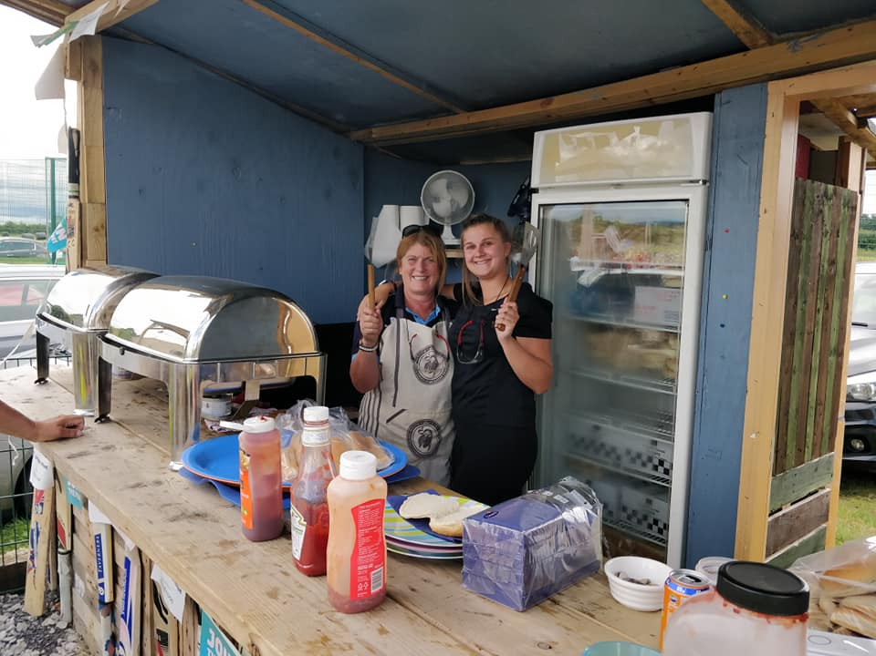
Ladies’ section taking on BBQ duties for Hawarden Village school’s sports day.

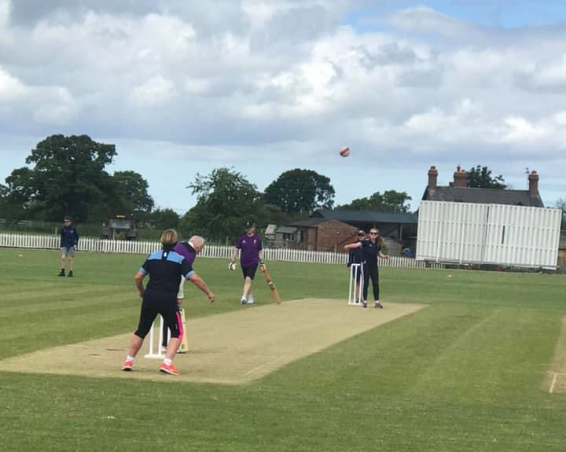
Visually impaired cricket vs Cheshire Cobras
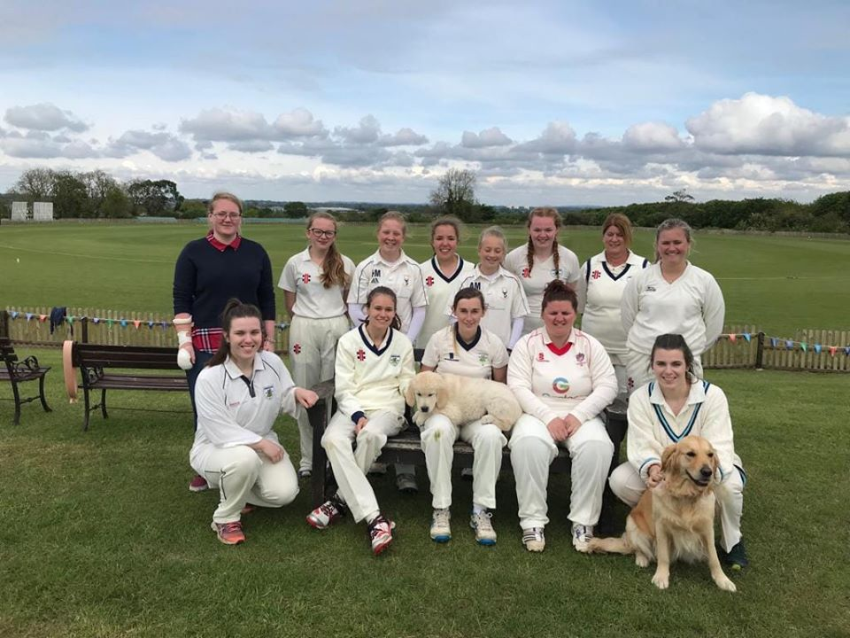
Team photo from the 2019 season.

