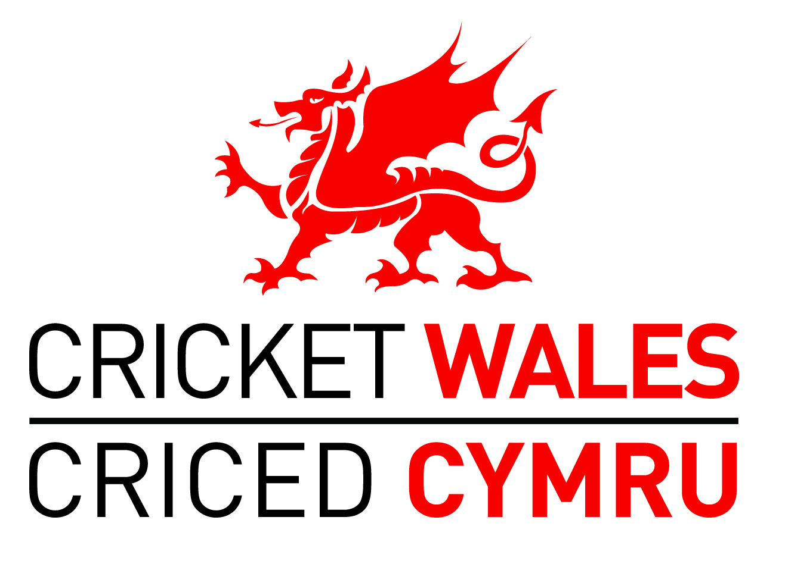

Equality Monitoring Report Foundation and Preliminary Level

Background

Cricket Wales is committed to enabling cricket to be accessible to all. Our commitment includes:

- Being aware of the current profile of the Cricket Wales Board and Staff in terms of equality.
- Developing and implementing an equality policy.
- Publicising our commitment to equality.
- Undertaking Human Resources and Communications audits.

This will be accomplished by upholding the principles of equality in all aspects of our work. We will audit and monitor our business activities regularly, and take appropriate steps if it appears that our commitment to equality is not being achieved effectively.

As part of this commitment we have a rolling plan to collect data on the profile of our Board, Staff, Coaches, Officials and Members. Without this data it will not be possible to identify any current areas of under-representation or potential inequalities, and as such, it will make it much more difficult for us to tackle these issues.

The monitoring information will also greatly aid our efforts to ensure that all Board and Staff members are treated fairly regardless of age, race, disability, sex, gender identity, sexual orientation, caring responsibility, religion or belief.

This work is being carried out as part of our responsibilities under the Equality Act 2010 and as part of the accreditation process for the Foundation Level of the Equality Standard for Sport.

Cricket Wales Board and Staff

Methodology

The audit of Cricket Wales Board and Staff took place during December 2013/early January 2014 via the Cricket Wales Survey Monkey account. Individual’s anonymity was protected and the data was collated by the Cricket Wales CEO. Nine out of twelve Board Directors completed the survey (75%); twenty eight out of thirty staff members completed the survey (93%).

We work with good practice principles in equality data collection which will help us to:
- Standardise the data collected so it can be compared now and in the future.
- Compare our profile against local demographic data collected by organisations such as Local Authorities or from the 2011 Census.
- Identify a current snapshot of our organisation and then compare it to future profiles.
- Consider how representative our organisation is of our local communities.
- Plan positive action to encourage more involvement by different communities in our organisation.
- Apply for public funding.

Headline findings

The Cricket Wales Board and Staff consists of people from a very similar demographic background. The large majority are white, male, able-bodied and heterosexual, and have either a Christian faith or no religion. A good spread of ages exists within the Cricket Wales Board and Staff. (It is not possible to analyse the results separately for Board and Staff).

Comparisons with national demographics and membership of cricket clubs in Wales

When compared with national population statistics and the membership of cricket clubs in Wales, the following groups are most under-represented within Cricket Wales’ Board and Staff:

- Females 8% within Cricket Wales; 6% within cricket clubs in Wales; 50% within Wales
- Disabled people 3% within Cricket Wales; 1% within cricket clubs in Wales; 23% within Wales
- Those with a religion other than Christianity 0% Cricket Wales; 1.5% within Wales.

The proportion of non white individuals within Cricket Wales (5%) is slightly above the Wales population percentage (4%) but slightly below the percentage within cricket clubs in Wales (6%).

Coaches and Officials within Welsh Cricket

Methodology

The audit of Welsh Coaches and Officials was undertaken via the Cricket Wales Survey Monkey account and was supported by ACO Wales. Individual’s anonymity was again protected and the data was again collated by the CEO. 54 Coaches (>10% of Welsh ECB CA Members) and 31 Officials (>10% of ACO Wales membership) completed the survey.

Headline findings

As with the Board and Staff, Coaches and Officials in Wales have a similar demographic profile being predominantly male, white, heterosexual and either having no religion or a Christian faith. However, the age profile is older and more individuals have some form of disability. As with the Board and Staff, Coaches and Officials are under-represented amongst females and the disabled, when compared with the general Welsh population.

Conclusions and recommendations including areas for improvement

- The results of the above audits will form the basis of the Cricket Wales Equality Action Plan
- Cricket Wales will be undertaking a governance review during financial years 2013/14 and 2014/15. This will be wide-ranging but will include the consideration of a more diverse, skills-based Board. Females and those with a disability are currently under-represented compared to the Wales population;
- Future recruitment of staff also needs to be influenced by a current under-representation amongst females and those with a disability;
- Part of the Equality Action Plan will involve following the Disability Sport Wales Insport process;
- Cricket Wales’ Workforce Plan needs to consider the development of greater diversity amongst Coaches and Officials.
Equality Monitoring Profile Cricket Wales
Number of Board and Staff | 42
Forms not returned | 5
Forms returned | 37
Sex | Number | % |  | Age | Number | %
Preferred not to say | 0 | 0% |  | Under 18 | 0 | 0
Male | 34 | 92% |  | 18 - 24 | 3 | 8%
Female | 3 | 8% |  | 25 - 34 | 10 | 27%
Total | 37 | 100% |  | 35 - 44 | 4 | 11%
 |  |  |  | 45 - 54 | 9 | 24%
Disability | Number | % |  | 55 - 64 | 9 | 24%
Preferred not to say | 1 | 3% |  | 65 - 74 | 2 | 5%
No | 35 | 94% |  | 75+ | 0 | 0%
Yes | 1 | 3% |  | Total | 37 | 100%
Total | 37 | 100%
Detail |  |  |  | Ethnic Group | Number | %
Deafness or partial hearing loss | 0 |  |  | Preferred not to say | 1 | 3%
Blindness or partial sight loss | 0 |  |  | White | 34 | 91%
Learning disability | 0 |  |  | Asian | 1 | 3%
Learning difficulty | 0 |  |  | African | 0 | 0%
Developmental disorder | 0 |  |  | Caribbean or Black | 1 | 3%
Physical disability | 0 |  |  | Other ethnic group | 0 | 0%
Mental health condition | 0 |  |  | Total | 37 | 100%
Long term illness or disease | 1
Other | 0 |  |  | Religion | Number | %
 |  |  |  | Preferred not to say | 6 | 16%
Gender reassignment | Number | % |  | No religion | 13 | 35%
Preferred not to say | 3 | 8% |  | Christian (all) | 18 | 49%
Yes | 0 | 0%
No | 34 | 92% |  | All non-Christian | 0 | 0%
Total | 37 | 100% |  | Total | 37 | 100%
Sexual orientation | Number | % |  | Caring responsibility | Number | %
Preferred not to say | 5 | 14% |  | Preferred not to say
Gay man | 0 | 0% |  | Yes
Gay woman/lesbian | 0 | 0% |  | No
Heterosexual/straight | 32 | 86% |  | Total
Other | 0 | 0%
Total | 37 | 100

Equality Monitoring Profile Cricket Wales
Number of Coaches /Officials | 72
Number of Coaches | 54
Number of Officials | 31
Sex | Number | % |  | Age | Number | %
Preferred not to say | 0 | 0% |  | Under 18 | 0 | 0
Male | 67 | 93% |  | 18 - 24 | 7 | 10%
Female | 5 | 7% |  | 25 - 34 | 8 | 11%
Total | 72 | 100% |  | 35 - 44 | 8 | 11%
 |  |  |  | 45 - 54 | 20 | 28%
Disability | Number | % |  | 55 - 64 | 18 | 25%
Preferred not to say | 2 | 3% |  | 65 - 74 | 10 | 14%
No | 62 | 86% |  | 75+ | 1 | 1%
Yes | 8 | 11% |  | Total | 72 | 100%
Total | 72 | 100%
Detail |  |  |  | Ethnic Group | Number | %
Deafness or partial hearing loss | 1 | 1% |  | Preferred not to say | 2 | 3%
Blindness or partial sight loss | 1 | 1% |  | White | 68 | 94%
Learning disability | 1 | 1% |  | Asian | 1 | 1%
Learning difficulty | 0 | 0% |  | African | 0 | 0%
Developmental disorder | 1 | 1% |  | Caribbean or Black | 1 | 1%
Physical disability | 3 | 4% |  | Other ethnic group | 0 | 0%
Mental health condition | 0 | 0% |  | Total | 72 | 100%
Long term illness or disease | 4 | 6%
Other | 1 | 1% |  | Religion | Number | %
 |  |  |  | Preferred not to say | 4 | 6%
Gender reassignment | Number | % |  | No religion | 29 | 41%
Preferred not to say | 2 | 3% |  | Christian (all) | 37 | 52%
Yes | 1 | 1%
No | 68 | 96% |  | All non-Christian | 1 | 1%
Total | 71 | 100% |  | Total | 71 | 100%
Sexual orientation | Number | % |  | Caring responsibility | Number | %
Preferred not to say | 4 | 6% |  | Preferred not to say
Gay man | 1 | 1% |  | Yes
Gay woman/lesbian | 0 | 0% |  | No
Heterosexual/straight | 62 | 87% |  | Total
Other | 4 | 6%
Total | 71 | 100

Name: Peter Hybart
Position: CEO
Date: 28th January 2014

Source – www.ons.gov.uk

