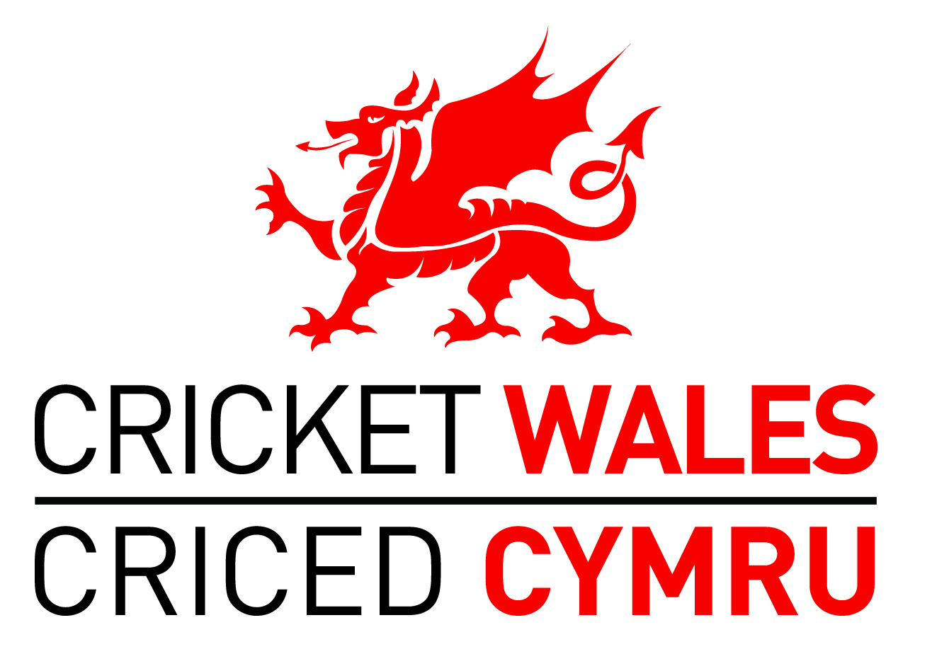

CRICKET WALES EQUALITY ACTION PLAN
Introduction and Strategic Context
- Cricket Wales exists ‘to lead, inspire and influence the growth, quality and accessibility of cricket in Wales’. The accessibility of the sport plays an important role within the above Mission Statement and has also been identified as one of five strategic objectives within the Cricket Wales Outcomes Framework:

‘SO2 - Cricket is easily accessible to everyone in Wales’

- This Equality Action Plan is an important element of Cricket Wales’ plans to improve accessibility to the sport; plans that will under-pin the delivery of the above objective. The Plan will also form an important element of Cricket Wales’ bid for the Foundation and Preliminary Levels of the Equality Framework for Sport (March 2014).

- To date, the work on the Equality Framework for Sport has included:

- The development of a formal Equality Policy by the Cricket Wales Board and the promotion of this policy to all Welsh cricket networks;
- The identification of lead Equality Officers: Chairman Roger Morris (Volunteers) and CEO Peter Hybart (Staff);
- An audit of Cricket Wales Board and Staff, and a sample of Coaches and Officials (see Appendix 1 for results);
- An audit of current Human Resource procedures and policies (see Appendix 2 for results);
- An audit of current Communications practice (see Appendix 3 for results).

- In addition to the specific work on the Equality Framework, Cricket Wales:

- Collects data relating to the Equality agenda within its annual audit of clubs;
- Has developed a Women and Girls Innovation Plan for the development of the women and girls’ game;
- Has recently brought disability cricket into Cricket Wales by dissolving the Welsh Association of Cricketers with a Disability (WACD).

The Equality Action Plan

- This Equality Action Plan builds on the work done to date and focuses on:

- A Cricket Wales governance review between February 2014 and the 2015 Cricket Wales AGM. This will consider the skill-set and diversity of the Board, the proposed new Area Forums, Junior Council and Senior Council and the relationships between these bodies;

- A new four-year Disability Plan which includes Cricket Wales applying for the various levels of the Disability Sport Wales (DSW) Insport accreditation process;

- The ongoing delivery of the Cricket Wales Women and Girls’ Innovation Plan;

- A new focus on engaging with a Black/Minority Ethnic (BME) community that exists in parts of Wales and is passionate about the game. In particular, this will focus on looking to integrate midweek cricket more within the Cricket Wales ‘family’;

- Ongoing consideration of equality and diversity when recruiting new staff and within HR policies;

- An annual audit of a sample of coaches and officials and the development of female/BME/disabled coaches and officials as part of the Workforce Plan;

- The delivery of a Communications Plan that embraces the principles of equality and diversity;

- The development of an Equality Training Plan for Board and Staff
Summary
- Cricket Wales is committed to enabling cricket in Wales to be accessible to all. The draft Equality Action Plan is detailed below and in the following appendices. Following Board amendment and approval the Plan will be sent to the following individuals and organisations for consultation – women’s and girls’ coaches/volunteers; disability cricket personnel; Disability Sport Wales; midweek league volunteers; Street Games; ECB staff involved in the diversity and disability agendas; Junior Council; Senior Council; affiliated clubs and Glamorgan Cricket. Once finalised its delivery will be monitored on an annual basis. Consideration will be given to establishing a sub-group of the Board to accelerate this agenda and support the monitoring process.

