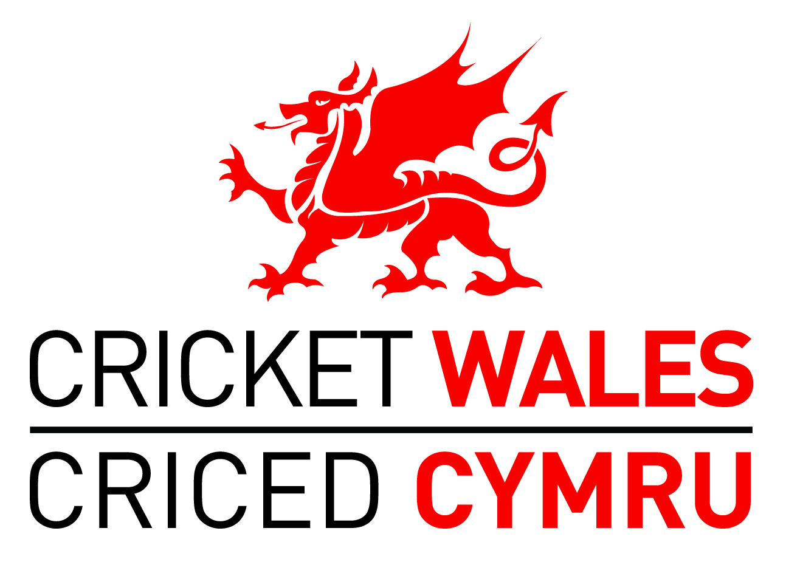

A CONSULTATION PAPER RELATING TO THE FUTURE MAKE-UP OF THE CRICKET WALES BOARD AND SUB-STRUCTURE
Background
- During summer 2014 the Cricket Wales Board agreed to establish a Governance Working Group to consider the future governance of recreational cricket in Wales. See Appendix A for the Terms of Reference and membership of the Cricket Wales Governance Working Group.

- During the Autumn and Winter months the Group has met on a number of occasions and identified four broad areas for further development:

  - the future make-up of the Cricket Wales Board;
  - the future make-up of the Cricket Wales sub-structure that sits immediately beneath the Board;
  - closer joint working with Glamorgan Cricket;
  - ensuring that Cricket Wales is able to successfully oversee the whole of the recreational game in Wales.

- Point 2.3 above will involve the establishment of a Wales Cricket Steering Group and a Wales Cricket Operations Management Group that will involve the Officers and Senior Staff of both Cricket Wales and Glamorgan. These groups will commence in Spring 2015 with their purpose being to provide increased structure around existing joint-working, and to further develop areas of mutual interest such as talent development, commercial opportunities, community activity and the profile of cricket in Wales. The establishment of these groups requires no changes to the Memorandum and Articles (constitution), of either organisation.

- Further work is required in relation to point 2.4 above during the 2015 playing season, with the intention being to introduce new affiliation and accreditation processes from season 2016 onwards. More detail will be provided on these during Autumn and Winter 2015/16.

- The purpose of this paper is to consult with the whole game on points 2.1 and 2.2 above i.e. the proposed future make-up of the Cricket Wales Board and Sub-Structure.

The Current make-up of the Cricket Wales Board and Sub-Structure

- The current structure is illustrated in Appendix B. Underneath the Cricket Wales Board the current Sub-Structure consists of the Junior Council (junior leagues/regions), the Senior Council (senior leagues and Wales Minor Counties) and the Wales Association of Cricket Officials (Wales ACO). Each of these organisations elect representatives from their number to sit on the Cricket Wales Board (three from the Senior Council, two from the Junior Council and one from Wales ACO). These individuals are joined on the Board by three individuals from cricket clubs in Wales with ‘special skills’ required to help run a modern sporting organisation. These skills are currently finance, welfare/safeguarding and membership communications. Finally Glamorgan Cricket also nominate three individuals to sit on the Cricket Wales Board making the total number of voting Directors twelve. The Chairman is elected annually by the Board from within its number, the CEO has no voting rights and funding partners (Sport Wales and the ECB), attend meetings in an observer capacity.

The Code of Good Governance for sport in Wales

- Over the past twelve months Sport Wales and all of the fifty two National Governing Bodies (NGB’s) in Wales have developed a framework that covers important governance principles and leadership skills/behaviours that will be required by all NGB’s by March 2019. See Appendices C and D for this framework that has played an important role in guiding the Cricket Wales Governance Working Group on what the future make-up of the Cricket Wales Board and Sub-Structure should look like.

The future make-up of the Cricket Wales Board

- In line with the Code and consistent with modern best practice, it is proposed that the future make-up of the Cricket Wales Board includes individuals with the specific skills required to help run a modern sporting organisation, who are from diverse backgrounds and who can bring a measure of independence to the Board. The Board should also include a link to Glamorgan and a strong connection to the grass-roots game.

- More specifically it is proposed that the Board is made up as follows:

  - Three individuals with ‘Specific Skills’ required to help run a modern sporting
organisation. These individuals should be members of cricket clubs in Wales, should be recruited against specific role descriptions and should be interviewed for their positions to ensure they possess the appropriate skills and behaviours. Once appointed they should be ratified by the AGM on an annual basis. The skills and individuals required should change according to the needs of Cricket Wales at the time. (It is suggested that Finance, Welfare and Membership Communications should continue as the three specific skills required in the short term with the incumbent Directors continuing in their roles).

  - An additional three individuals who are also members of cricket clubs in Wales and may or may not be involved in the administration of the game at club, league, region or association level. Each individual will be interviewed against a standard Board role description and person specification. The final selection will take into consideration skills, behaviours, diversity, junior/senior game, geography and balance with the rest of the Board. Individuals will be appointed for three-year terms (‘staggered’ so that not everyone starts and finishes at the same time) with each individual only able to serve for a maximum of six consecutive years. New individuals should be ratified at the AGM. These individuals would represent Cricket Wales on each of the three Area Boards described below.

  - The individuals described in the paragraphs above will be nominated and seconded by organisations affiliated to Cricket Wales, and will be appointed by an interview panel whose potential membership could include the Chair, funding partners and one of the ‘Independents’ described below. It is recognised that the precise make-up of the selection panel will be of fundamental importance in recruiting Board Directors who can lead the game during challenging times.

  - Two nominations from Glamorgan Cricket ratified annually at the Cricket Wales AGM. One of these nominations would be expected to be the Glamorgan CEO.

  - Three individuals (‘Independents’), who do not play an active part in the administration of any cricket organisation in Wales, recruited from diverse backgrounds but with the ability to check and challenge our thinking at a Board level. These roles to be advertised and individuals recruited against specific skill-sets so as to add a new dimension to Cricket Wales Board membership, discussion and debate. Individuals to be appointed for three year terms (staggered), with each individual only able to serve for a maximum of six consecutive years. The potential membership of the interview panel could include the Chair, funding partners and Glamorgan Cricket and is again of fundamental importance in recruiting the right balance of individuals and skills to help move cricket forward.

  - A Chair to be elected by the Board from within its number or recruited by the Board from within or outside of cricket. The Chair’s term of office to be consistent with their term as a Director. A deputy Chair to be elected annually by the Board from within its number.

  - The Cricket Wales CEO to have voting powers.

  - Funding partners to attend Board meetings as observers.

- The above structure maintains the recreational game in the simple majority on the Board and preserves the link with Glamorgan, but also introduces independence and the opportunity of greater diversity for the very first time.

The future make-up of the Cricket Wales Sub-Structure

- It is proposed that the Sub-Structure underneath the Board is comprised as follows:

  - Three Cricket Wales Area Boards covering North Wales, South East Wales and South West Wales. Pembrokeshire to be part of the South West Area Board and Mid Wales organisations to be part of their nearest Area Board. (More specifically Breconshire and Radnorshire organisations to be part of the South East Area Board, Montgomeryshire organisations to be part of the North Wales Area Board and Ceredigion organisations part of the South West Area Board).

  - Each Cricket Wales Area Board to be formally constituted within the Cricket Wales Memorandum and Articles of Association. The role of each Area Board is to provide an area response to the Cricket Wales strategy and to co-ordinate the cricket organisations within its membership to deliver initiatives that will benefit the game in line with the Cricket Wales strategic plan.

  - Each Cricket Wales Area Board will have a Chair to provide leadership and a Secretary to perform administrative functions. Co-ordination, guidance and support will be provided by Cricket Wales staff who will develop a close working relationship with the above individuals and all membership organisations.

  - The membership of the Cricket Wales Area Boards will be made up of the leagues, regions and associations in each Area, together with additional individuals who can help in the co-ordination and delivery of the Cricket Wales strategy in the Area, and perhaps also provide player insight. It is important that each cricket organisation in the Area is represented. The Chair of each Area Board may come from within its membership, may be the individual from the Cricket Wales Board referred to in paragraph 9.2 or alternatively may be an independent appointment.

  - Area Boards will be Cricket Wales branded with the potential for resources to be devolved to them once their delivery arrangements are proven as fit-for-purpose.

  - Cricket Wales Area Boards will be given true responsibility and in so doing will become a fundamental part of the future of Cricket Wales.

  - Strong Area Boards will enable the national Cricket Wales Board to play a more strategic overseeing role guiding the future direction of the game in Wales.

  - The Junior and Senior Council will continue as advisory bodies meeting as required. Their discussions will need to complement those of the Cricket Wales Area Boards. As the new structure becomes established there may be a lesser role for the Councils to play.

  - A finance, commercial and general purpose committee shall continue as a sub-committee of the Board (consisting of Board Directors)

  - The Welfare Council consisting of the Welfare Director’s team will continue to meet on an ad hoc basis and will lead Cricket Wales in embedding all ECB Safeguarding policies, and achieving NSPCC Level 3 accreditation.

  - The Equality, Diversity and Inclusion (EDI) Action Group will continue to meet to oversee the Equality Action Plan and lead Cricket Wales towards the Intermediate Level of the Equality Standard for Sport.

  - Wales ACO and its branches will continue as a vitally important individual- member organisation that also acts as a region of the ECB ACO. Like all organisations affiliated to Cricket Wales, Wales ACO will be able to nominate individuals to serve as Board Directors as described in paragraph 9.3. The Wales ACO branches will be a key part of the Cricket Wales Area Boards.

- The proposed new make-up of the Cricket Wales Board and Sub-Structure is illustrated in Appendix E.
Implementation time-line
- This consultation paper will be circulated widely throughout the game during March, and April with the process including meetings of the Junior and Senior Council. Views and responses will be collated and presented in a final paper to the Cricket Wales Governance Working Group on 7th May and the Cricket Wales Board on 28th May 2015. Further consultation with the game will take place during the summer should it be required.

- During the summer work will also progress in preparing for the establishment of the three Cricket Wales Area Boards through meetings with the constituent member organisations and development of appropriate governance documentation. It is recognised that the three Areas of Wales are at different stages of evolution and may require slightly different approaches to achieve their potential.

- Resolutions relating to the required changes to the Cricket Wales Articles of Association will be taken to the Autumn 2015 Cricket Wales AGM.

- A period of transition will exist after the AGM during which the current Board will continue to oversee the business while the new Board is recruited. It is hoped to have the new Board in place by Christmas 2015.

- The Cricket Wales Area Boards will formally come into existence after the AGM and will spend Autumn/Winter 2015/16 establishing themselves and preparing their response to the Cricket Wales strategy within their Area.

Consultation Response
- Views on this important consultation paper relating to the future make-up of the Cricket Wales Board and Sub-Structure should be forwarded to

peter.hybart@cricketwales.org.uk

by 5pm on Thursday 30th April 2015

